Smooth upgrading of process plants with the HIQuad X
New flexible safety system simplifies plant modernization
(Brühl, 14 August 2019)
HIMA Paul Hildebrandt GmbH, world's leading independent provider of smart safety solutions for industrial applications, has brought a new programmable safety system onto the market. The flexible and scalable HIQuad X is a further development of the HIQuad, which has been securing over ten thousand applications worldwide for around 30 years. It fits seamlessly into HIMA’s Smart Safety Platform.
The HIQuad X is not just a flexible, efficient safety system; it is also an important component in HIMA’s new, technically coherent Smart Safety Platform, which unifies all HIMA safety systems. Hardware and software are closely aligned. Plant operators thus receive a scalable solution which they can use to cover the complete safety and security requirements for small single applications right through to complex architectures of large-scale plants in line with requirements.
The Smart Safety Platform is based on the use of basic components which are identical for all HIMA product families, including operating system, engineering tool and communication via SafeEthernet. The fact that platform components can be combined freely means that virtually every customer solution can be developed and implemented. The holistic approach enables companies to use a solution from one source, thereby reducing the complexity of their plants considerably.

New performance dimensions, flexible system architecture and integrated intrinsic safety (Ex protection)
With the implementation of the proven platform technology, the HIQuad X reaches a new performance dimension. Users thus benefit from a reduced system cycle and reaction time, particularly for floating point calculations. The increased diagnostic capability, which permits quicker defect tracking during maintenance work, provides additional benefits. On the one hand the more flexible system architecture enables the timely use of redundant modules right through to complete redundancy. On the other hand retrospective adaptations to the system for application programs, hardware and communication can be undertaken - even during operation.
The HIQuad X system also enables the use of SIL3 modules with integrated intrinsic safety (Ex protection). Users no longer need a separate isolation amplifier for their intrinsically safe SIL circuits. The benefits of the diagnostics provided can therefore be utilized up to the field device without any losses. Other benefits include the simplification of planning, documentation and furnishing proof of the intrinsic safety. The fact that flawed plant outages due to defective isolation amplifiers are no longer an issue is another huge bonus. This is made possible by the redundant connection options which always permit the exchange of defective system components during operation.
The HIQuad X system can of course be connected with every basic process control system (BPCS), even on a redundant pathway. It then continues to run independently even if an error occurs in the BPCS or in the communication. The security mechanisms which are installed assist with this process. They create a virtual and also a physical separation when standard protocols are used.
HIMA customers who already use HIQuad systems benefit from the upgrade to HIQuad X with short plant outages and considerably reduced costs when compared to new installations. The I/O modules including field wiring can continue to be used. This enables users to make savings in terms of investment and costs for testing and documentation.
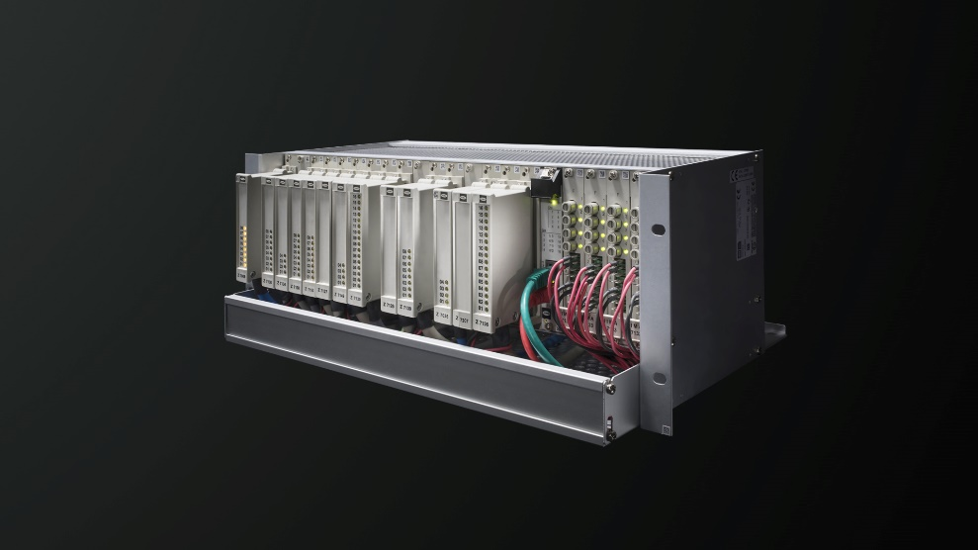
Figure: HIMA has brought a new programmable safety system onto the market in the form of the HIQuad X.
Image © HIMA Paul Hildebrandt GmbH

About HIMA
The HIMA Group is the world's leading independent provider of smart safety solutions for industrial applications. With more than 35,000 installed TÜV-certified safety systems worldwide, HIMA qualifies as the technology leader in this sector. Its expert engineers develop customized solutions that help increase safety, cyber security and profitability of plants and factories in the digital age. For over 45 years, HIMA has been a trusted partner to the world's largest oil, gas, chemical, and energy-producing companies. These rely on HIMA solutions, services and consultancy for uninterrupted plant operation and protection of assets, people and the environment. HIMA’s offering includes smart safety solutions that help increase safety and uptime by turning data into business-relevant information. HIMA also provides comprehensive solutions for the efficient control and monitoring of turbomachinery (TMC), burners and boilers (BMC) and pipelines (PMC). In the global rail industry, HIMA’s CENELEC-certified SIL4 COTS safety controllers are leading the way to increased safety, security and profitability. Founded in 1908, the family-owned company operates from over 50 locations worldwide with its headquarters in Bruehl, Germany. With a workforce of approximately 800 employees, HIMA generated a turnover of approximately €123 million in 2017.
For more information, please visit: www.hima.com

Press contact HIMA Headquarters

HIMA Paul Hildebrandt GmbH
Daniel Plaga
Group Manager Global PR

Albert-Bassermann-Straße 28
68782 Bruehl
Phone: +49 6202 / 709-405
Cell : +49 172 / 3224 944
E-Mail: d.plaga@hima.com

Agency press contact / Please send voucher copies to

Mark Herten, Publitek  Bäckerstrasse 6, 21244 Buchholz  Phone: +49 (0)4181 968 09820  Mobile: +49 (0)1520 748 3901  E-Mail: mark.herten@publitek.com | Carsten Otte, Publitek  Phone: +49 (0)4181 9680 09880  Mobile: +49 (0)1520 915 8629  E-Mail: carsten.otte@publitek.com

